**LAB ACTIVITIES**

**Name: Kulsoom Khurshid**

**Reg #: SP20-BCS-044**

**Course: Operating System**

**ACTIVITY 1:**

This activity is related to file permission. Perform the following tasks

1. Create a new directory named test in root directory as super user.

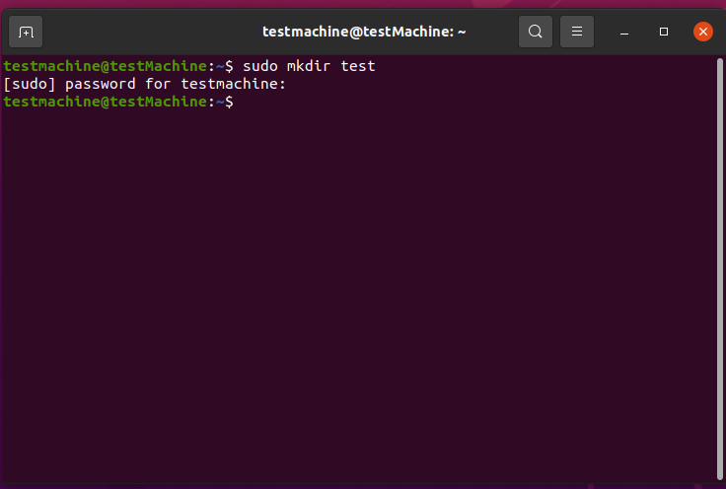

1. Make this directory public for all.

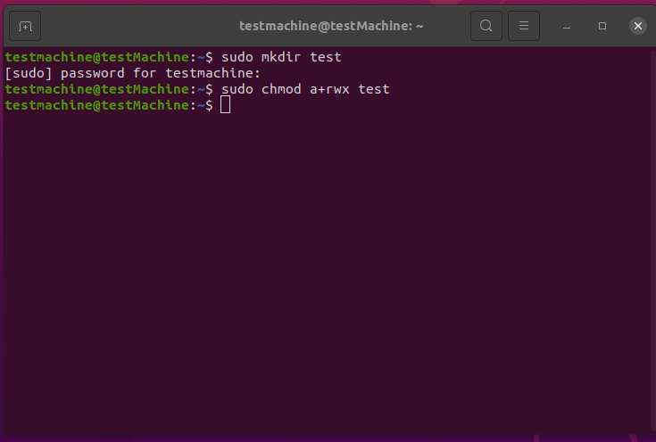

1. Create a file “testfile.txt” in /test directory.

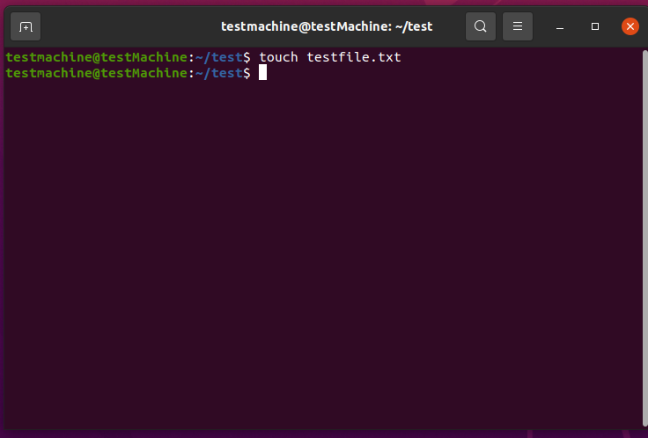

1. Change its permissions that no boy can write the file, but the owner can read it.

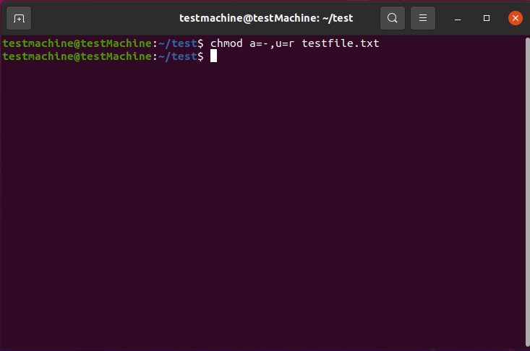

1. Create another user “Usama”.

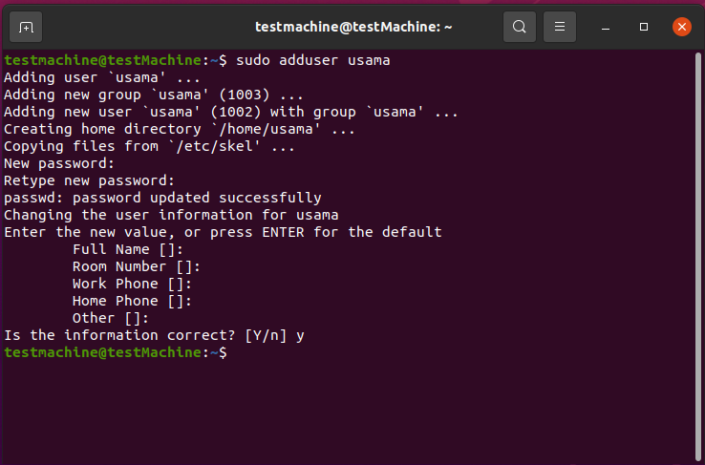

1. Run the shell with user Usama.

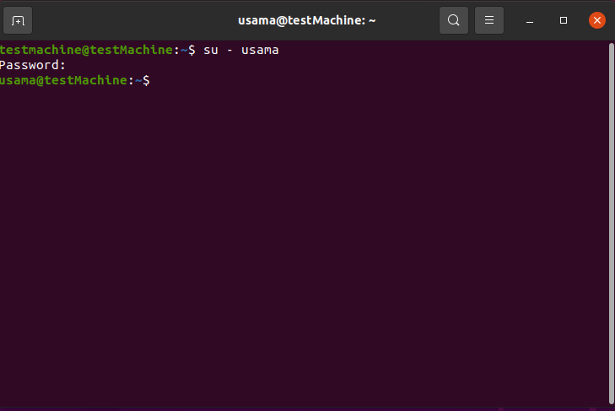

1. Try to read the “testfile.txt”.

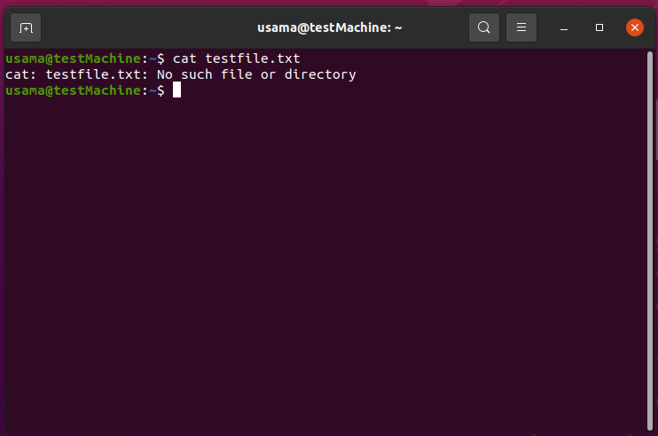

1. Logout as Usama.

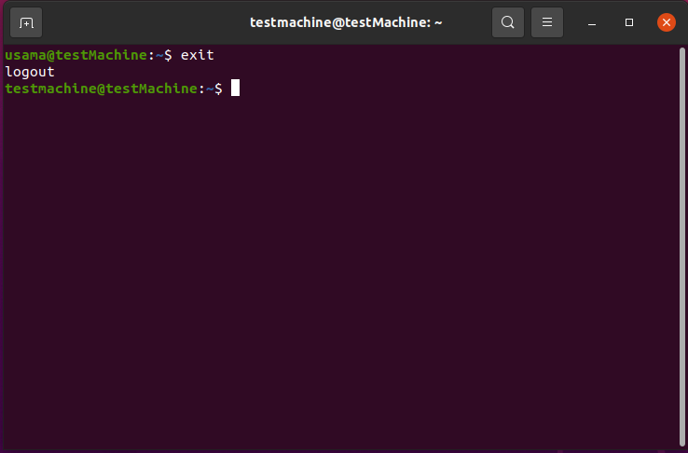

1. Change the permission of testfile.txt so that everyone can read, write and execute it.

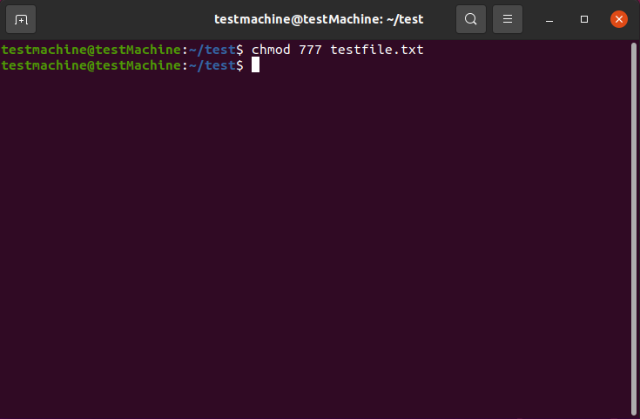

1. Run shell as Usama again.
2. Now, read the file.

**ACTIVITY 2:**

Perform the following activities

1. Set the permission such that a newly created file is readable only to the owner.
2. Create a text file “act.txt” in /test directory crated in previous activity.

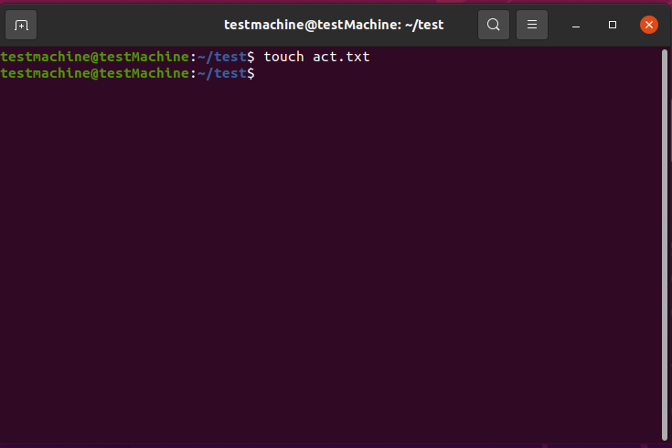

1. Run the shell as user “Usama” (created previously).
2. Access the file “act.txt”.

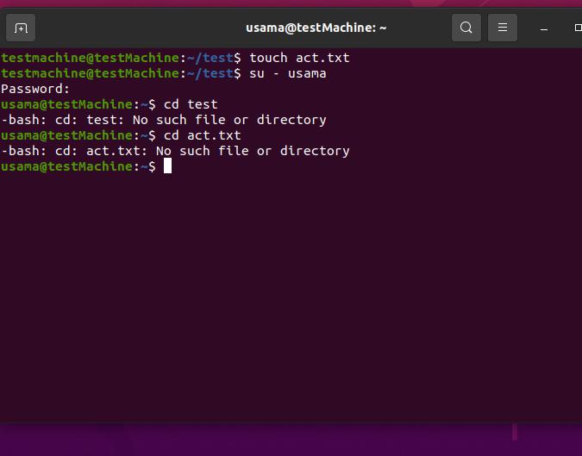

1. Logout as Usama.



1. Now change the ownership of the file from Ubuntu to Usama.
2. Run the shell again as Usama.

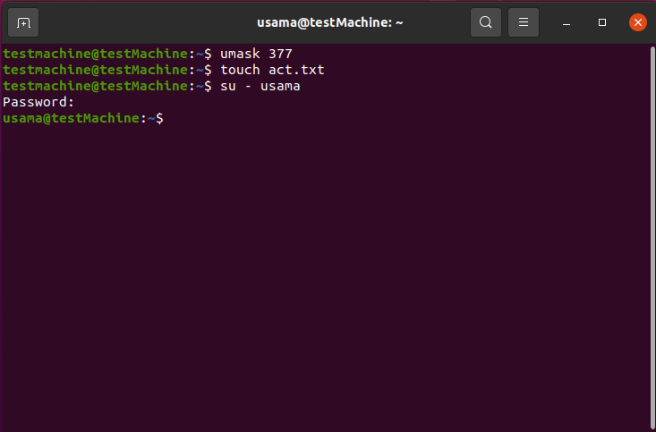

1. Read the file “act.txt” using cat command.



1. Logout as Usama.



1. Now access the act.txt with user Ubuntu.

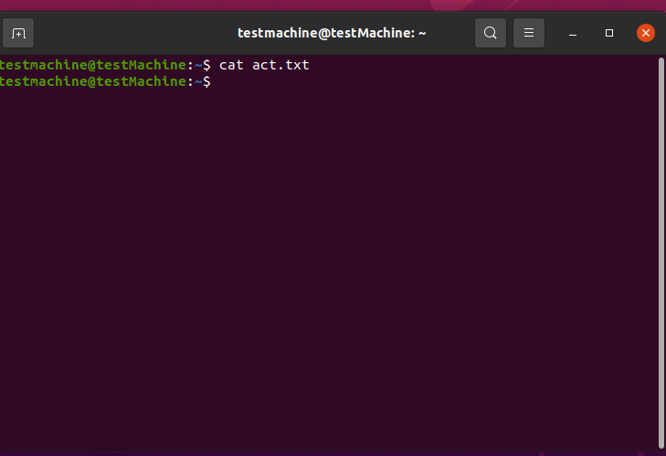

**ACTIVITY 3:**

Perform the following task.

1. Search apt repository for the chromium browser.

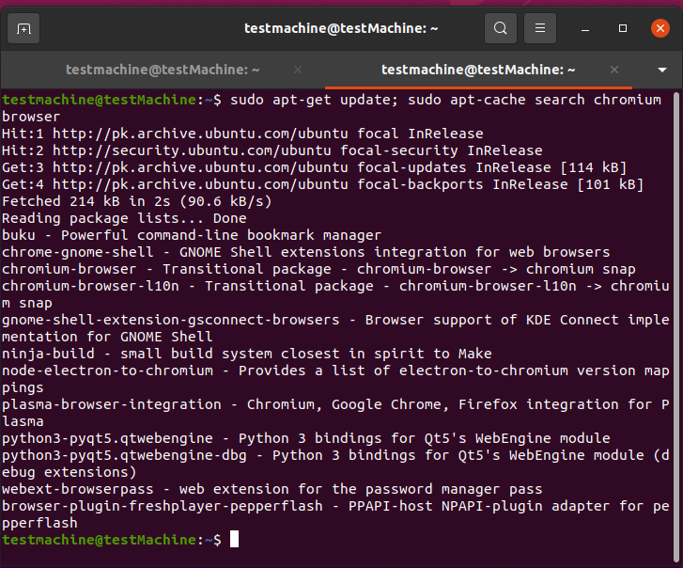

1. Install the chromium browser using command line.

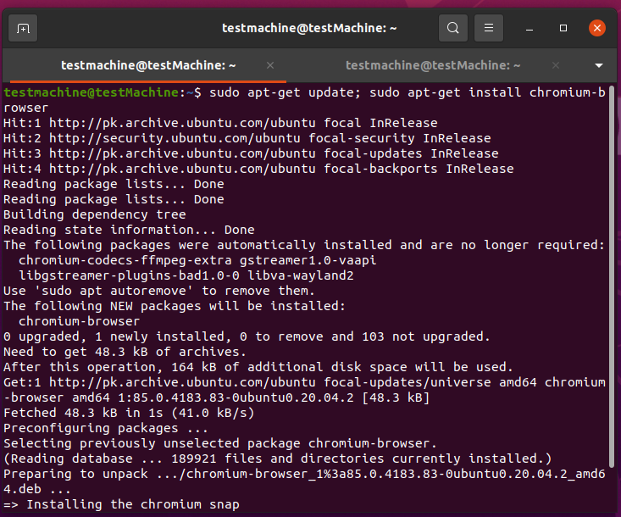

1. Write the command to update and upgrade the repository.

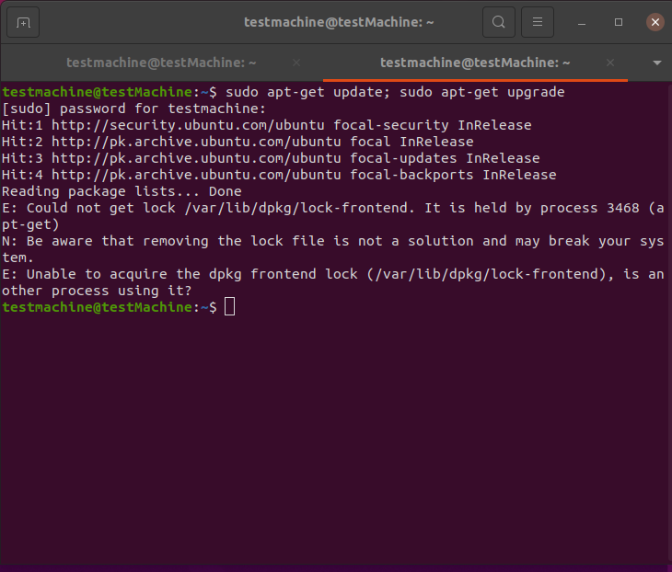

1. List the software installed on your machine and write output on a file list.txt.
2. Read the list.txt file using cat command.

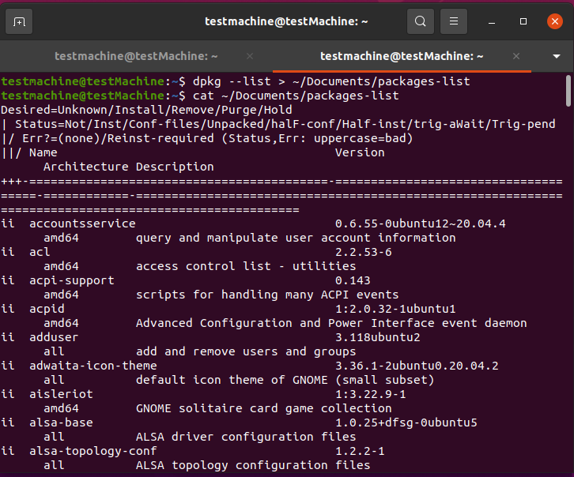

**HOME ACTIVITY:**

1. Familiar with adduser command using: man adduser/useradd, man groupadd useradd -​ create a new user or update default new user information. Create 3 user accounts (user1,​ user2, user3) and add 2 groups (gr1, gr2). Add user1 to gr1 and add user2, user2 to gr2.​ Check user ID (UID) and group ID (GID) by listing file /etc/passwd. Find lines with added​ user. What is the UID and GID for these accounts? Write command which show UID and GID​ for your user name:​

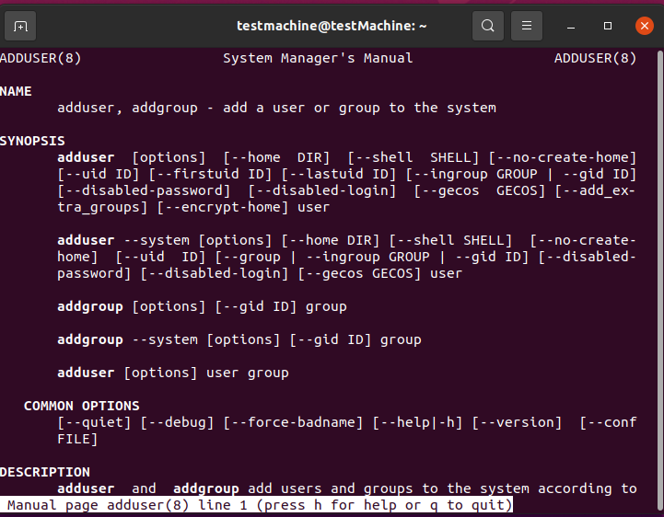

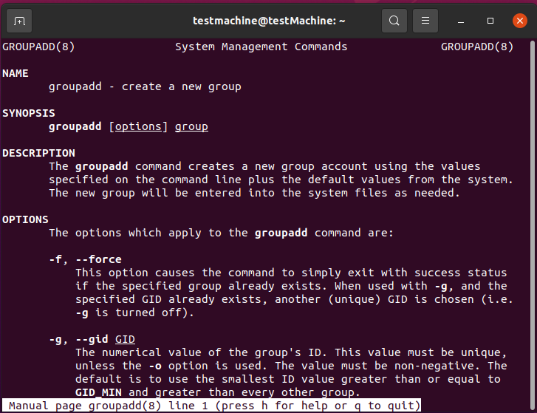

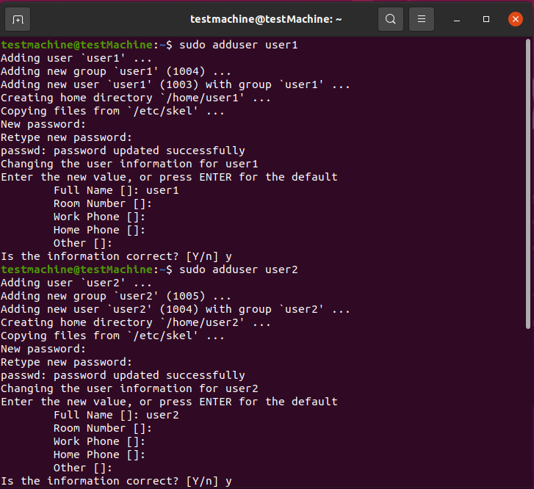

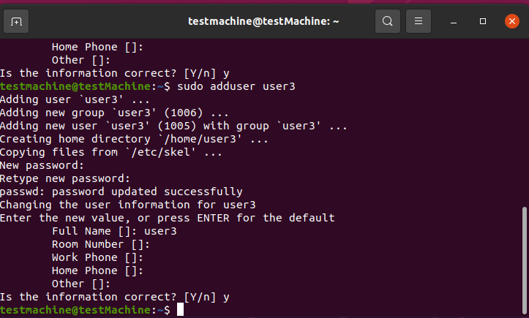

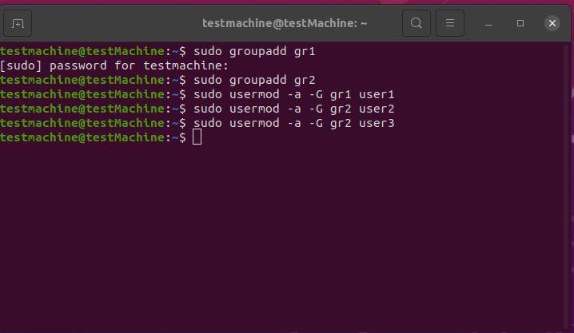

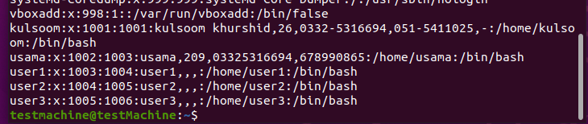

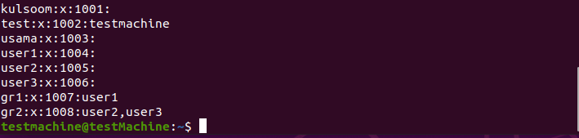

1. Create 3 files with touch command: files1, files2, files3.​

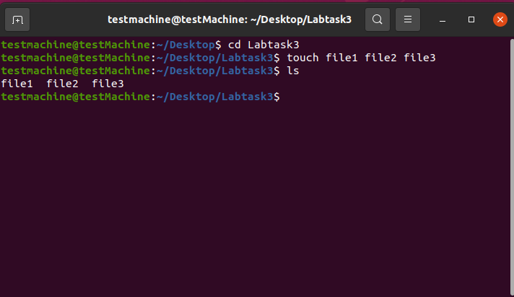

1. Write the command line by using letters with chmod to set the following​ permissions:​

- rwxrwxr-x for file1​

- r-x—x—x for file2​

- ——xrwx for file3

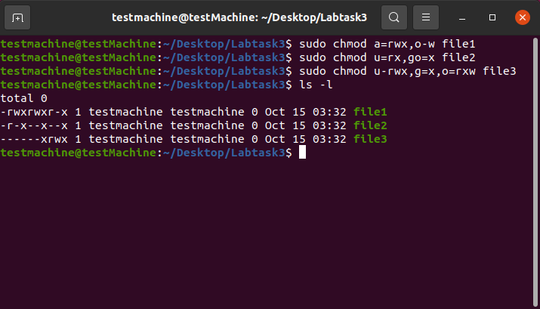

1. Write the command line by using numbers with chmod to set the following​ permissions:​

- rwxrwxrwx for file4 (you have to prepare this file)​

- -w------- for file5 (you have to prepare this file)​

- rwx--x—x for folder1 (you have to prepare this folder)​

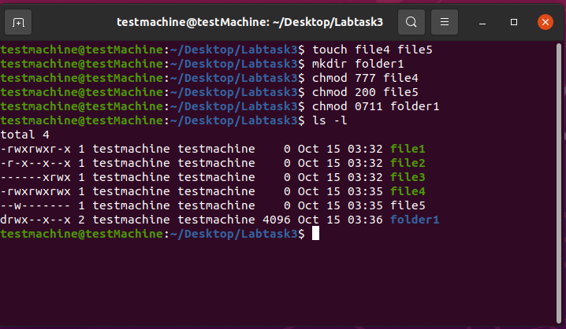

1. Create two user accounts: tst1 and tst2 Logging in id: tst1, group users, with bash​ shell, home directory /home/tst1 Logging in id: tst2, group public, with bash shell, home​ directory home/tst2 For the two accounts set a password.​

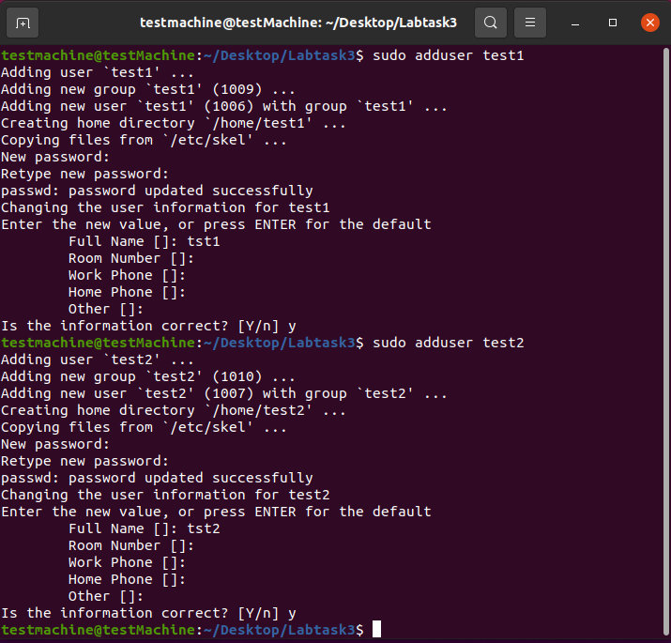

1. Logging in as tst1 and copy /bin/ls into tst1 home directory as myls file. Change the owner of ​myls to tst1 and the permissions to 0710. What does this permission value mean?​ Logging in as tst2 and try to use /home/tst1/myls to list your current directory. Does it work?​

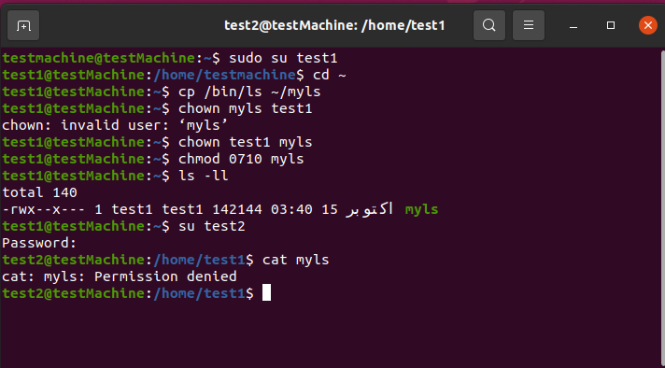

1. Create a new group labs with tst1 and tst2. Change the owner group of myls file to labo. Try again from tst2 account to execute /home/tst1/myls to list your current directory. Does it work? ​

